Programme: Erasmus +, K2, Strategic Partnership; ID KA2-VET-20/17
Project Title: Networking for Entrepreneurship
Project Acronym: NET-ENT
Grant Agreement No.: 2017-1-SI01-KA202-035580 Project Website: http://netent.scng.si/
Partner: City of Glasgow College

DISSEMINATION AND EXPLOATATION REPORT
Dissemination /Exploatation | Date | Place | Target groups | Number of Participants | Evidences
Project Launch | August 2018 | COGC | Whole college  Project audience - Students, lecturers, industry participants and mentors. | 1000s  120+ | 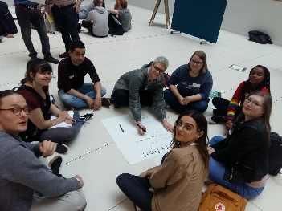  Presentations  Film footage  Photographs  Twitter Feed  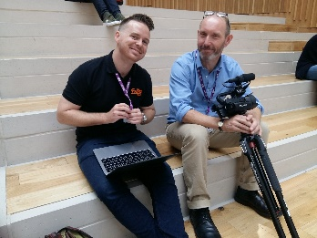
Faculty of Creative Industries  - Good Practice event  - Show & Tell event  - Good News stories  - Social Media | Sept. 2018  June 2019  June 2019  Feb. 2020 | COGC | Lecturers, Curriculum Heads  Associate Deans,  New Dean | 50+ | PP presentation  Student presentations & samples of products.  Article  Instagram
College Website | 2019 |  | Course applicants, teachers, students & general public |  | https://www.cityofglasgowcollege.ac.uk/work-with-us/european-projects-0
Young Enterprise Scotland/ John Mather Trust Enterprise Competition | 7th November 2019 | City Campus Business Suite, Glasgow | Entrants to competion | 20+ | Ideas Generation Workshop
Craftex Competition | May 2019 | Trades Hall, Glasgow | Students, Kelvin College, Clyde College,  Trade & Industry links. | 200+ | 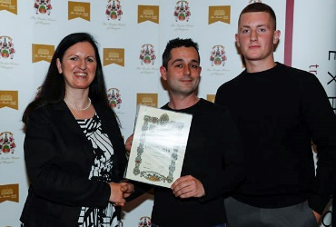  Photographs  Winners Certificates
End of Year Show | June 2019 | COGC | Students, applicants, family & friends of students, general public,  Industry guests | 200+ | 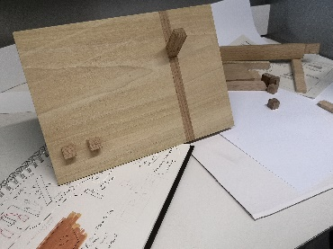  Photographs  Products on display
Design Council Shop | August 2019 | Buchanan Galleries, Glasgow | General public |  | Exhibition within the shop.
Delegation from Norway  Kvinnherad Vidaregåande Skule.  'Cross Curriculum Learning' | 7th November 2019 | COGC | Senior Managers, Managers and Lecturers | 57 | 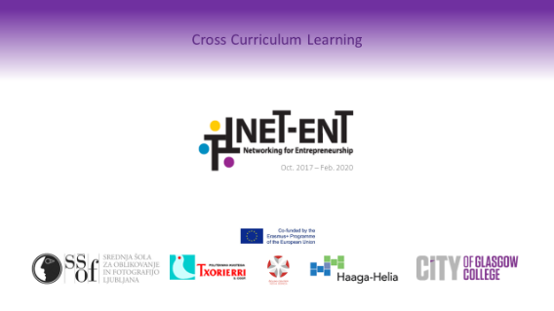  PP presentation  Samples of products displayed

