Programme: Erasmus +, K2, Strategic Partnership; ID KA2-VET-20/17
Project Title: Networking for Entrepreneurship
Project Acronym: NET-ENT
Grant Agreement No.: 2017-1-SI01-KA202-035580 Project Website: http://netent.scng.si/
Partner: __Haaga-Helia UAS_____

DISSEMINATION AND EXPLOATATION REPORT

Dissemination /Exploatation | Date | Place | Target groups | Number of Participants | Evidences
Social media post | 23.03.2018 | Haaga-Helia Startup School FB page (www.facebook.com/HHStartUpSchool/) | StartUp School students and external stakeholders | 2238 followers | 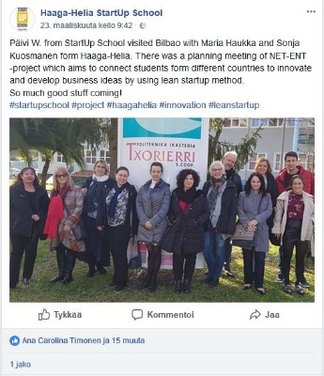
Social media post | 20.06.2018 | Haaga-Helia Startup School FB page | StartUp School students and external stakeholders | 2238 followers | 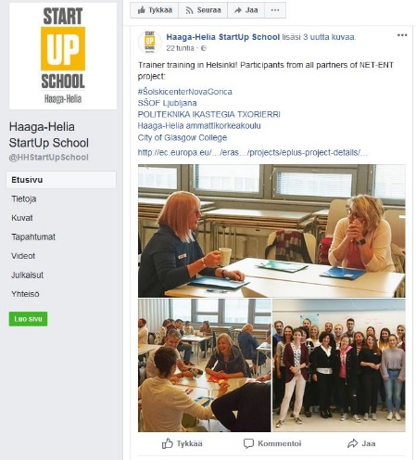
Social media post | 21.05.2019 | Haaga-Helia Startup School FB page | StartUp School students and external stakeholders | 2238 followers | 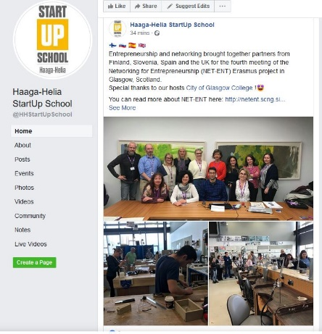
eSignals blog | 29.5.2019 | Haaga-Helia eSignals blog | Haaga-Helia external stakeholders and staff | N/A | https://esignals.haaga-helia.fi/en/2019/05/29/five-learnings-from-the-eu-erasmus-project/
Website | 1.10.2018 | Haaga-Helia RDI project website (in Finnish) | Haaga-Helia external stakeholders and staff | N/A | www.haaga-helia.fi/fi/net-ent
Website | 1.10.2018 | Haaga-Helia RDI project website (in English) | Haaga-Helia external stakeholders and staff | N/A | www.haagahelia.org/en/rdi-projects/net-ent-networking-entrepreneurship
Website | 1.10.2018 | Haaga-Helia StartUp School project website | StartUp School external stakeholders and staff | N/A | https://startupschool.fi/research-projects/

