Programme: Erasmus +, K2, Strategic Partnership; ID KA2-VET-20/17
Project Title: Networking for Entrepreneurship
Project Acronym: NET-ENT
Grant Agreement No.: 2017-1-SI01-KA202-035580 Project Website: http://netent.scng.si/
Partner: Politeknika Ikastegia Txorierri

DISSEMINATION AND EXPLOITATION REPORT

Dissemination /Exploatation | Date | Place | Target groups | Number of Participants | Evidences
Information on Politeknika Txorierris website | November 2017 | webpage | Audience in general | Thousands of visitors | http://www.txorierri.net/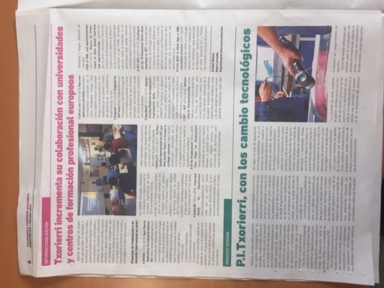
Informing about the first meeting in Politeknika Txorierris social networks | November | Facebook, instagram and twitter | Audience in general | 1070 followers on facebook | 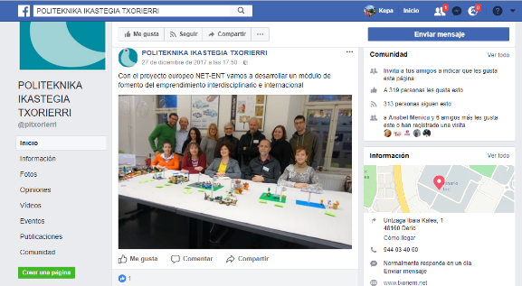
We have an internationalization leaflet informing about what it is going on in the internationalizaion department | Ongoing | Mostly in our school when we recive visits, but also in EfVET conference, Tknika events... | Stackeholders, policy makers, teachers, vet providers... | 500 copies
20/04/2018 | Regional | Erasmus+ KA2 projects Dissemination event in the Basque Country in Tknika, Errenteria | 64 people attending the event | VET international coordinators from the Basque Counyry, managers, teachers… | https://www.tknika.eus/en/cont/dissemination-event-erasmus-ka2-projects-in-the-basque-country/  Attendance list  Photocall with our logo  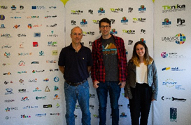
20/04/2018 | Regional | Tknika Erasmus+ KA2 projects Dissemination event :  They handed out Booklets with information about our project | 200 Booklets will be handed out | VET centers, public, subsidized and private | https://issuu.com/inakitelleria/docs/proyectos-ka2_issue  Booklet  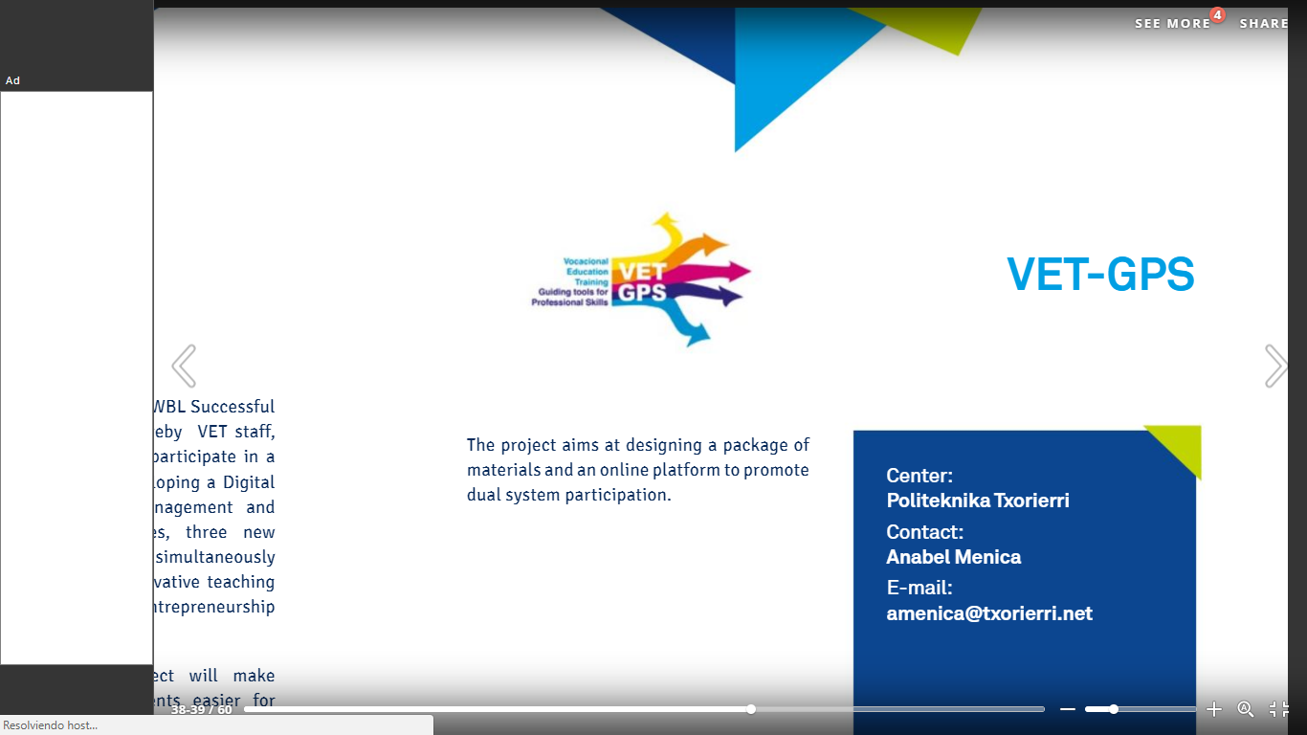
20/04/2018 | EUR | Tknika published an article in Unevoc https://unevoc.unesco.org  In this article there is a link to the booklet where you can read the information related to our project https://www.tknika.eus/en/cont...he-exchange-of-good-practices/ | ¿? | TVET experts, VET policy-makers, researchers and practitioners | https://unevoc.unesco.org/go.php?q=e-Forum+-+Message+Board&skin=efor&lang=en&action=threadlist&thread=3958  Screenshot article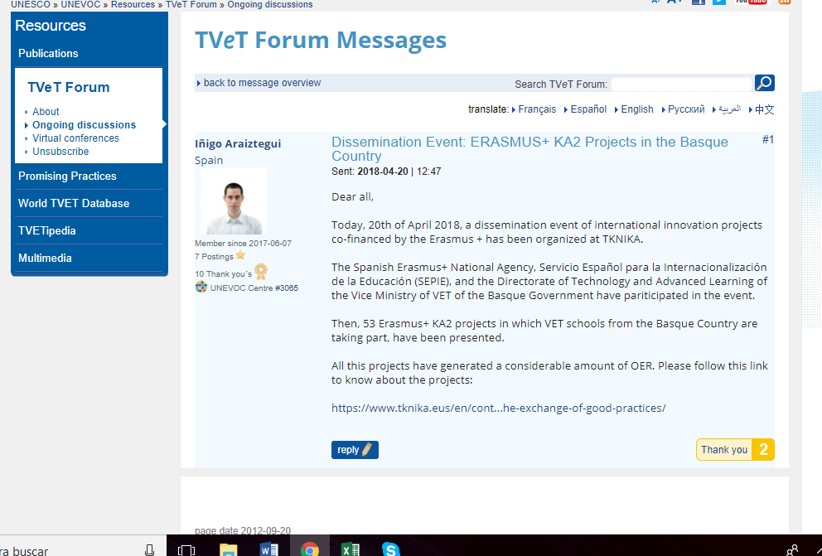
20/04/2018 | N | Tknika published an article of the event on Twitter. | They have 3205 followers | VET centers, companies, students… | Tweet screenshot Tknika  https://twitter.com/tknika
20/04/2018 | R | We did two Round tables explaining the project in the event in Tknika | 15 people | VET european proyect coordinators, VET managers and teachers | Roundtables  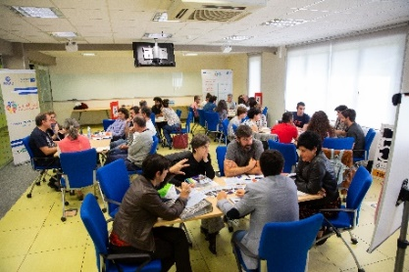
Informing about the second meeting in Politeknika Txorierris social networks | March 2018 | Facebook, instagram and twitter | Audience in general | 1070 followers on facebook | 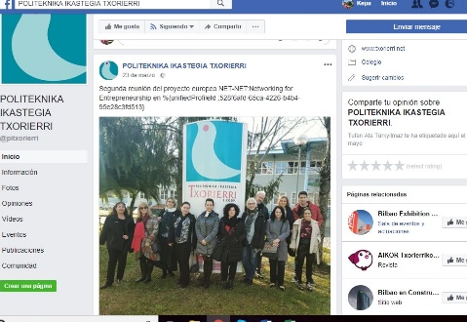
Informing about the Training in Finland in HETEL´s webpage plus retuit in Politeknikas Txorierri social networks | June 2018 | HETEL webpage plus  Politeknika Txorierris  Facebook, instagram and twitter | Audience in general | Thousands | 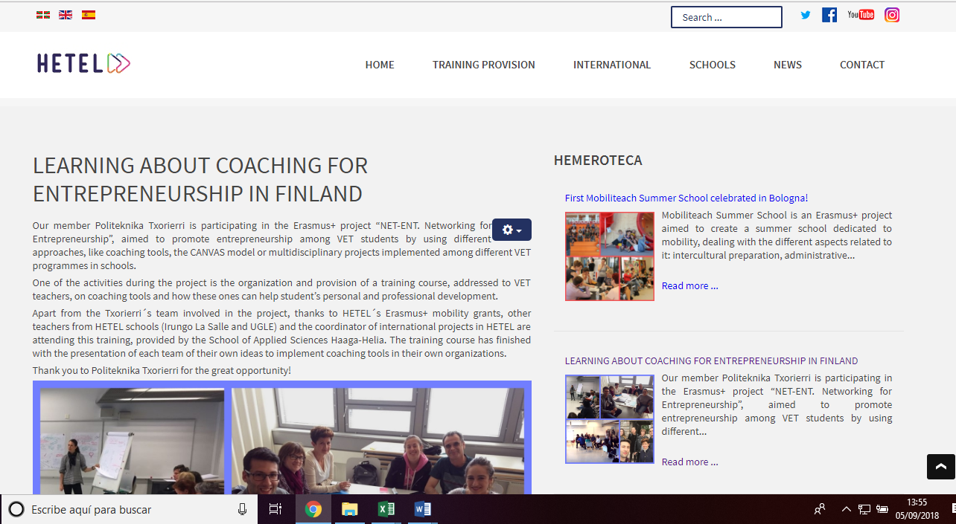  https://www.hetel.eus/index.php/en/news/546-aprendiendo-sobre-coaching-para-el-emprendimiento-en-finlandia-3
Internationalization day at Tknika: Event to promote European Projects | July 9th 2018l | Tknika | Vet providers, VET trainers, trainees, VET managers/counsellors, civic society and policy makers, companies providing | 55 attendees | 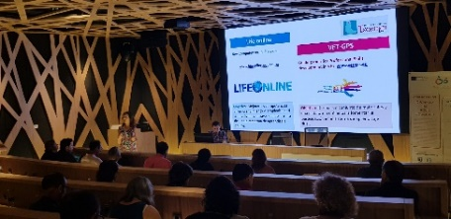
A 30 page broachure informing about the project | Ongoing | Events, ... | Stackeholders, policy makers, teachers, vet providers... | 100 brochures | 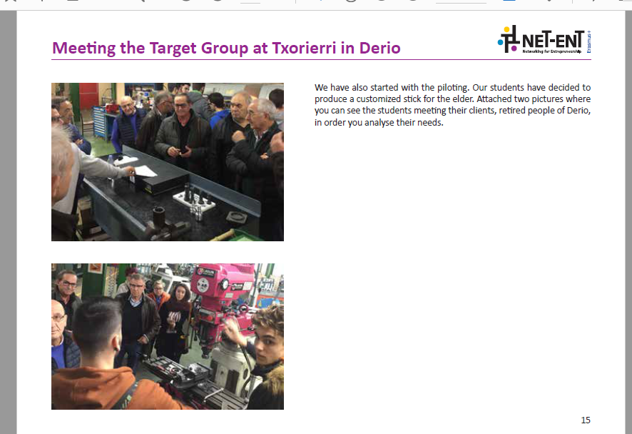
An article published in our newspaper, Berritzen, informing about the project | December 2018 | Schools newpaper | Public in general, VET centers, students | 4500 distributed copies | Proof
Informing about the Glasgow meeting in Politeknika Txorierris social networks | May 2019 | Facebook, instagram and twitter | Audience in general | 1070 followers on facebook | https://cutt.ly/VrQ0cxZ  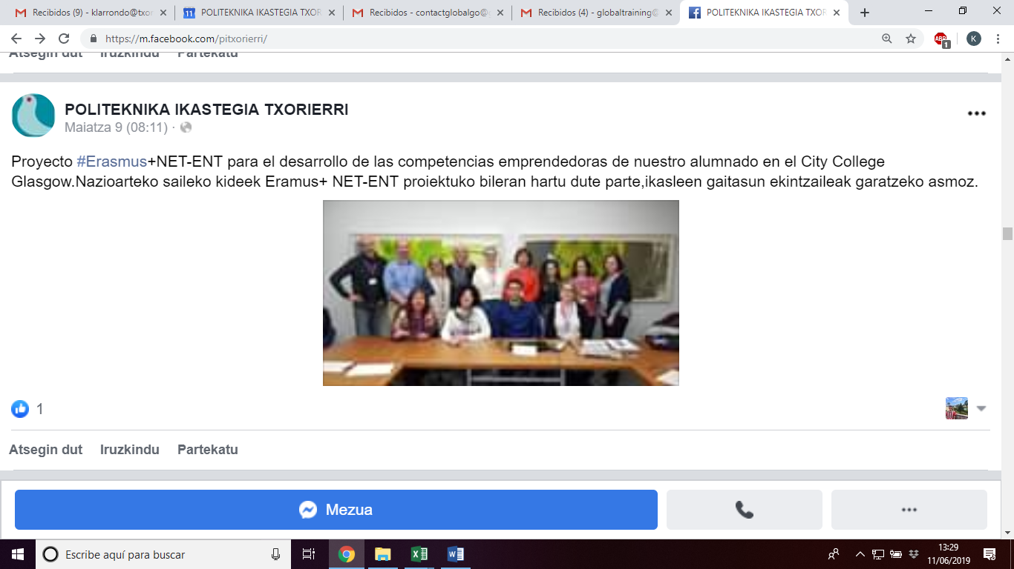
Article in regional newpaper about net-ent piloting | May 2019 | Aikor | Audience in general | More than 1000 copies | 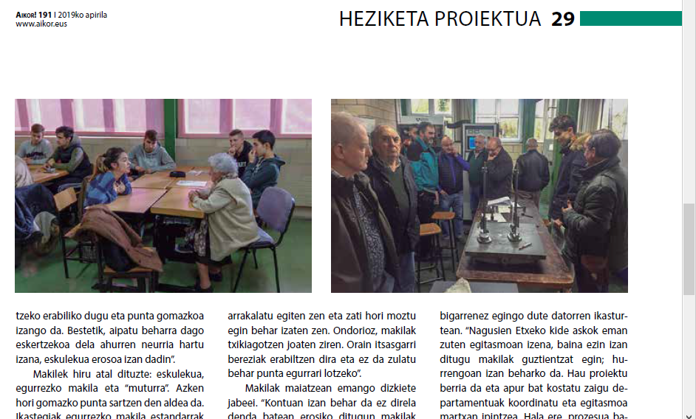  Proof. Aikor
Presented the project | 0/11/2018 | Politeknika Txorierri | Peter Waglund and Anita Bolkeus. They both work in the municipality in Sweden |  | 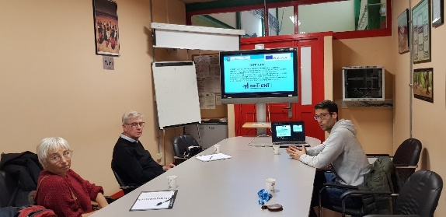
Article in Politeknikas Txorierris webpage | 2018 | Website | Audience in general | Thousands of people | https://cutt.ly/DrQ2bPj
Erasmus+ KA2 Project Dissemination Event | 11th April 2019 | TKNIKA, Hernani | VET international coordinators from the Basque Country, managers, | 100 people Teacher, VET Centres from Europe | Proof: Attendance list signed  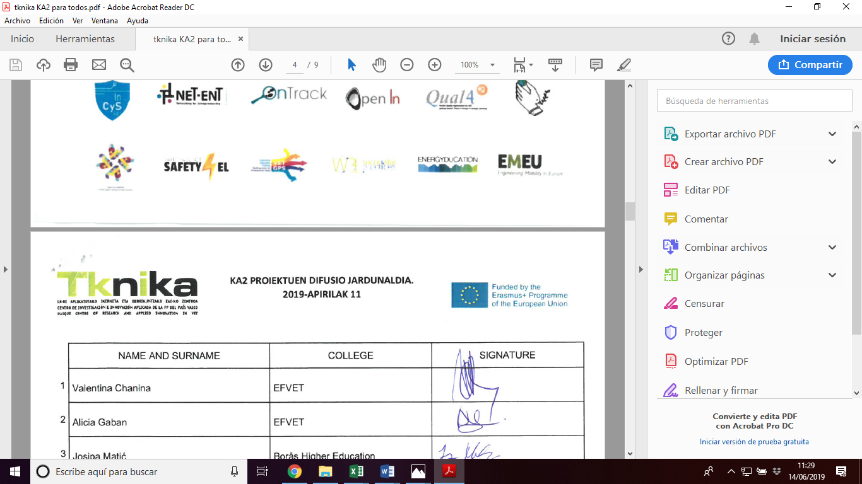
Tknika booklet | 11th April 2019 | Booklets handed out in Tknika | 6000 | 600 differnt institutions  5000 people reached | https://tknika.eus/en/cont/proyectos/ka2-projects-cooperation-for-innovation-and-the-exchange-of-good-practices/
8th Edition of the International Conference New Perspectives in Science Education in Florence, Italy | 22nd March 2019 |  | TVET experts, VET policy-makers, researchers and practitioners | 171 people | 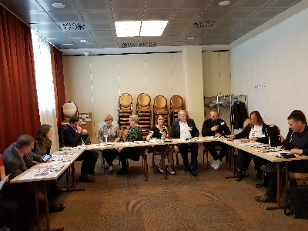
Erasmus+ Ka2 projects Summary | 04/06/2019 | EfVET TT coordinators meeting Tknika | EfVET coordinators | 40
Erasmus+ Ka2 projects Summary | Ongoing | Ka2 booklet (online) https://tknika.eus/en/ | Vet providers, students, teachers... | 4000 | https://tknika.eus/en/cont/proyectos/ka2-projects-cooperation-for-innovation-and-the-exchange-of-good-practices/

