Programme: Erasmus +, K2, Strategic Partnership; ID KA2-VET-20/17
Project Title: Networking for Entrepreneurship
Project Acronym: NET-ENT
Grant Agreement No.: 2017-1-SI01-KA202-035580 Project Website: http://netent.scng.si/
Partner: _SŠOF Ljubljana______________________

DISSEMINATION AND EXPLOATATION REPORT

Dissemination /Exploatation | Date | Place | Target groups | Number of Participants | Evidences
Information on website | 2017-2020 | Web pages SŠOF  OBLIKOVNA | general public,  students,  teachers | undisclosed | https://oblikovna.si/projekti/erasmus/net-ent-3/  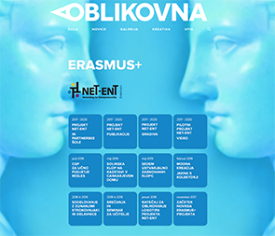
Conference for teachers | 15. Nov. 2018 | SŠOF Ljubljana | Teachers / SŠOF | 61 | 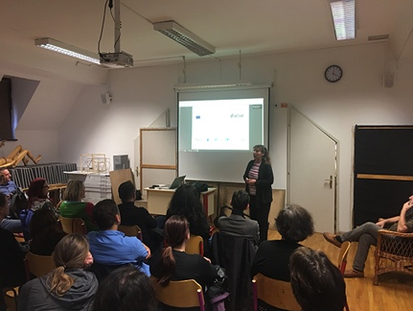
Seminar for teachers | 28. Nov. 2018 | SŠOF Ljubljana | Art Teachers from primary schools | 68 | 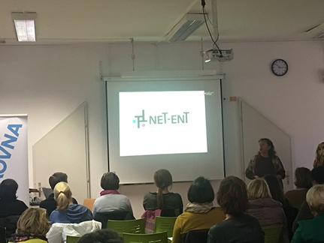
Magic of Wood (Čar lesa) post on RTV MMC | 13. May 2019 | RTV MMC channel | general public | undisclosed | https://www.rtvslo.si/zabava/lepota-bivanja/car-lesa-lep-topel-na-dotik-disi-s-strunami-skupaj-tudi-lepo-zveni/487945  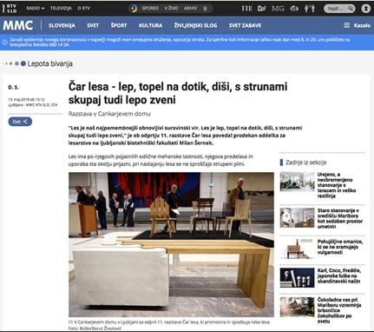
Magic of Wood (Čar lesa) exhibition in CD | 13.-18. May 2019 | National Cultural Centre Cankarjev dom / Ljubljana | general public, wood experts, designers  and other professional public | N/A | https://www.cd-cc.si/kultura/razstave/car-lesa-2019  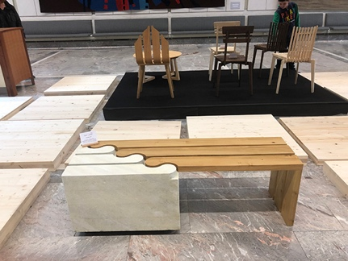
Magic of Wood (Čar lesa) exhibition in Pivka | 19.-30. May 2019 | Krpanov dom, Pivka | general public | N/A | https://carlesa.si/fotografije-dogodkov/2019-krpanov-dom-v-pivki/
Magic of Wood (Čar lesa) exhibition in Velike Lašče | 31. May – 2. July 2019 | Občina Velike Lašče (Levstikov dom) | general public | N/A | https://carlesa.si/fotografije-dogodkov/car-lesa-2019-levstikov-dom-v-velikih-lascah/  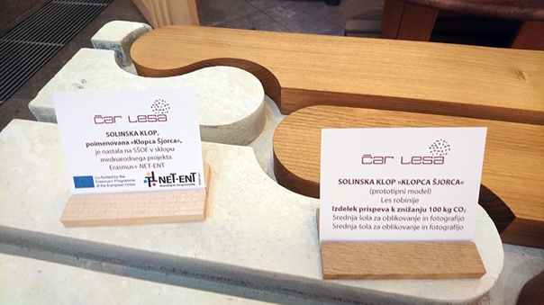
Magic of Wood (Čar lesa) exhibition in Koper | 3. – 21. July 2019 | Univerza na Primorskem | general public | N/A | https://carlesa.si/fotografije-dogodkov/car-lesa-2019-palaca-armerija-rektorat-up-v-kopru/  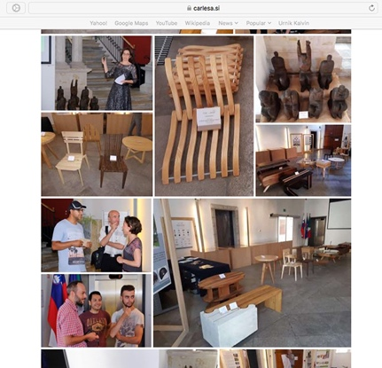
Magic of Wood (Čar lesa) exhibition in Arboretum | 22. July – 1. August 2019 | Arboretum / Volčji potok | general public | N/A | https://carlesa.si/fotografije-dogodkov/car-lesa-2019-arboretum-volcji-potok/  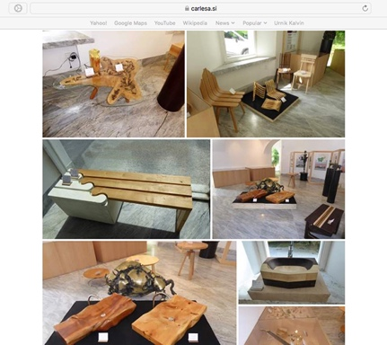
Magic of Wood (Čar lesa) exhibition in Radovljica | 1.-19. August 2019 | Radovljiška graščina | general public | N/A | https://carlesa.si/fotografije-dogodkov/car-lesa-2019-radovljiska-grascina-v-radovljici/  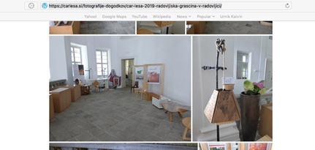
Magic of Wood (Čar lesa) exhibition in Postojna | 19. Aug.-9. Sept. 2019 | Notranjski muzej Krasa,  Postojna | general public | N/A | https://carlesa.si/fotografije-dogodkov/car-lesa-2019-notranjski-muzej-krasa-postojna/
Magic of Wood (Čar lesa) exhibition in Celje | 10.-15. Sept. 2019 | MOS – Mednarodni obrtniški sejem, Celje | general and professional public | N/A | https://carlesa.si/fotografije-dogodkov/car-lesa-2019-mos-celje/  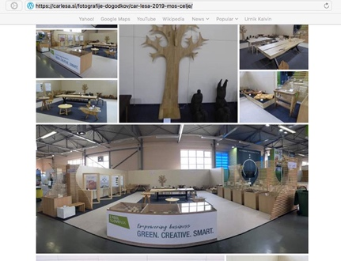
Magic of Wood (Čar lesa) exhibition in Ribnica | 16. Sept. – 9. Oct. 2019 | Rokodelski center Ribnica | general public | N/A | https://carlesa.si/fotografije-dogodkov/car-lesa-2019-rokodelski-center-ribnica/  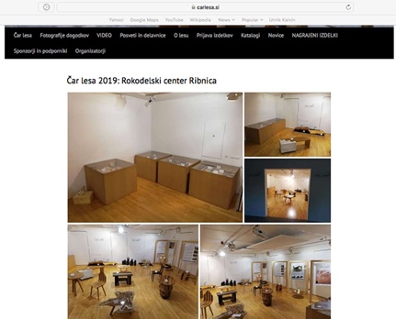
Magic of Wood (Čar lesa) exhibition in Nova Gorica | 10. Oct. – 13. Nov. 2019 | Občina Nova Gorica | general public | N/A | https://carlesa.si/fotografije-dogodkov/car-lesa-2019-mestna-obcina-nova-gorica/
Magic of Wood (Čar lesa) exhibition in Maribor | 14. Nov. – 1. Dec. 2019 | Vetrinjski dvor, Maribor | general public | N/A | https://carlesa.si/fotografije-dogodkov/car-lesa-2019-vetrinjski-dvor-maribor/  https://carlesa.si/video/
Catalogue Magic of Wood 2019 | 2019 | web pages | general and professional public | undisclosed | https://carlesadotsi.files.wordpress.com/2019/09/katalog-c48car-lesa-mos-2019.pdf
Article on  NET-ENT Erasmus+ pilot project | June 2019 | R5 Magazine  Year 2019 / No. XIII  pages 78-81  ISSN 2335-2884 | students, teachers, designers | 700 printed issues & web | https://oblikovna.si/publikacije/revija-r5/  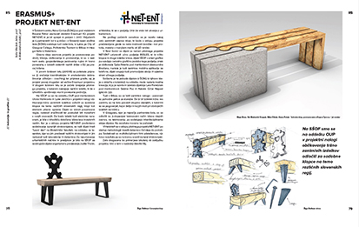
Article on the first finished product of NET-ENT pilot project / jacket with solar pannels | June 2019 | R5 Magazine  Year 2019 / No. XIII  page 32  ISSN 2335-2884 | students, teachers, designers | 700 printed issues & web | https://oblikovna.si/publikacije/revija-r5/  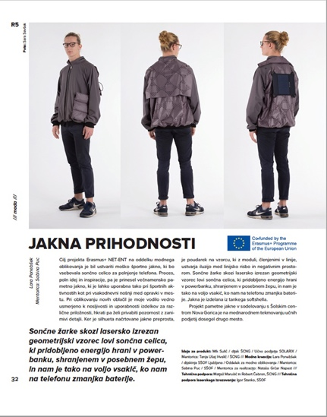
Video on pilot project  NET-ENT | 2019/2020 | YouTube  NET-ENT Channel | students, teachers, designers, general public | undisclosed | https://www.youtube.com/channel/UCQNmeEgA_0JKzmha5FVm3lQ  Product: Jacket with Solar Pannels (fashion design) / SŠOF  https://youtu.be/33H7xWhzOKc  Products: Benches fof Different Slovenian Regions / SŠOF  https://youtu.be/hD6-3Ivh8uE  Interviews with students, teachers and external expert  https://youtu.be/EYetxIKgumE
Brochure on NET-ENT project on 5 partner schools | 2020 | web pages SŠOF | students, teachers, designers, general public | undisclosed | https://online.fliphtml5.com/mmngr/tsyk/
Brochures on NET-ENT pilot project results on SŠOF | 2020 | web pages SŠOF | students, teachers, designers, general public | undisclosed | Product: Jacket with Solar Pannels (fashion design) / SŠOF  https://online.fliphtml5.com/mmngr/wqso/  Products: Benches fof Different Slovenian Regions / SŠOF  https://online.fliphtml5.com/mmngr/dwpq/  Product: Practice Firm RESLES / Corporate Identity / SŠOF  https://online.fliphtml5.com/mmngr/vvqj/
eTwinning | 2020 | eTwinning | teachers, students | undisclosed | https://twinspace.etwinning.net/96584/pages/page/899867
Post | 2020 | Facebook | students, teachers, designers, general public | undisclosed | https://www.facebook.com/pg/oblikovna/posts/?ref=page_internal  14. 04. 2020
Post | 2020 | Instagram | students, teachers, designers, general public | undisclosed | https://www.instagram.com/p/B-UECC3j4J-/

